**PAPER – III         PRACTICAL NO. : 02**

**AIM : WRITE PROGRAM TO DEMONSTRATE THE FOLLOWING ASPECTS OF SIGNAL ON SOUND /IMAGE DATA :**

1. **CONVOLUTION OPERATION**
2. **TEMPLATE MATCHING**

**ROLL NO. : 02                                BATCH : M.SC PART-I**

**DATE : 25/08/22**

**1] CONVOLUTION OPERATION :**

**CODE :**

from skimage.io import imread,imshow,show

from skimage.color import rgb2gray

import numpy as np

from scipy import ndimage,misc,signal

import matplotlib.pylab as pylab

im = rgb2gray(imread('E:/Msc Roll no. 02/Image processing/tiger3.jpg')).astype(float)

print(np.max(im))

print(im.shape)

blur_box_kernel=np.ones((3,3))/9

edge_laplace_kernel =np.array([[0,1,0],[1,-4,1],[0,1,0]])

im_blurred=signal.convolve2d(im,blur_box_kernel)

im_edges=np.clip(signal.convolve2d(im,edge_laplace_kernel),0,1)

fig,axes=pylab.subplots(ncols=3,sharex=True,sharey=True,figsize=(18,6))

axes[0].imshow(im,cmap=pylab.cm.gray)

axes[0].set_title('OriginalImage',size=20) # can use imshow instead of axes

axes[1].imshow(im_blurred,cmap=pylab.cm.gray)

axes[1].set_title('BoxBlur',size=20)

axes[2].imshow(im_edges,cmap=pylab.cm.gray)

axes[2].set_title('LaplaceEdgeDetection',size=20)

for ax in axes:

ax.axis('off')

pylab.show()

**OUTPUT :**

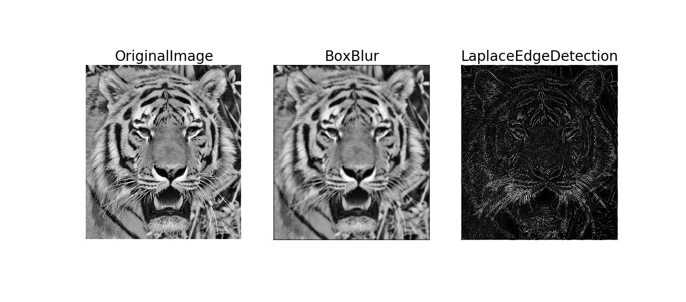

**2] TEMPLATE MATCHING :**

**CODE :**

from skimage.io import imread,imshow,show

from skimage.color import rgb2gray

import numpy as np

from scipy import ndimage,misc,signal

import matplotlib.pylab as pylab

#Applyingconvolutiontoacolor(RGB)image

im = imread('E:/Msc Roll no. 02/Image processing/tiger3.jpg').astype(np.float)

#readasfloat

print(np.max(im))

sharpen_kernel=np.array([0,-1,0,-1,5,-1,0,-1,0]).reshape((3,3,1))

emboss_kernel=np.array(np.array([[-2,-1,0],[-1,1,1],[0,1,2]])).reshape((3,3,1))

im_sharp=ndimage.convolve(im,sharpen_kernel,mode='nearest')

im_sharp=np.clip(im_sharp,0,255).astype(np.uint8)

im_emboss=ndimage.convolve(im,emboss_kernel,mode='nearest')

im_emboss=np.clip(im_emboss,0,255).astype(np.uint8)

pylab.figure(figsize=(10,15))

pylab.subplot(131),pylab.imshow(im.astype(np.uint8)),pylab.axis('off')

pylab.title('Original Image',size=25)

pylab.subplot(132),pylab.imshow(im_sharp),pylab.axis('off')

pylab.title('Sharpened Image',size=25)

pylab.subplot(133),pylab.imshow(im_emboss),pylab.axis('off')

pylab.title('Embossed Image',size=25)

pylab.tight_layout()

pylab.show()

face_image=misc.face(gray=True)-misc.face(gray=True).mean()

template_image=np.copy(face_image[300:365,670:750])

#righteye

template_image-=template_image.mean()

face_image=face_image+np.random.randn(*face_image.shape)*50

#addrandomnoise

correlation=signal.correlate2d(face_image,template_image,boundary='symm',mode='same')

y,x=np.unravel_index(np.argmax(correlation),correlation.shape)

fig,(ax_original,ax_template,ax_correlation)=pylab.subplots(3,1,figsize=(6,15))

ax_original.imshow(face_image,cmap='gray')

ax_original.set_title('Original',size=20)

ax_original.set_axis_off()

ax_template.imshow(template_image,cmap='gray')

ax_template.set_title('Template',size=20)

ax_template.set_axis_off()

ax_correlation.imshow(correlation,cmap='afmhot')

ax_correlation.set_title('Cross-correlation',size=20)

ax_correlation.set_axis_off()

ax_original.plot(x,y,'ro')

fig.show()

**OUTPUT :**

